SATURDAY 27 JUNE 2009
AT
FLEMING PARK LEISURE CENTRE
Passfield Avenue, Eastleigh,Hampshire,SO50 9NL
Open 10.00 am to 5.00 pm

SATURDAY 27 JUNE 2009
AT
FLEMING PARK LEISURE CENTRE
Passfield Avenue, Eastleigh,Hampshire,SO50 9NL
Open 10.00 am to 5.00 pm

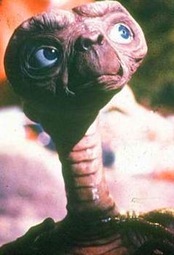
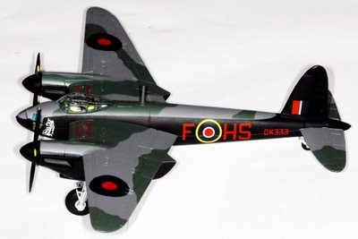
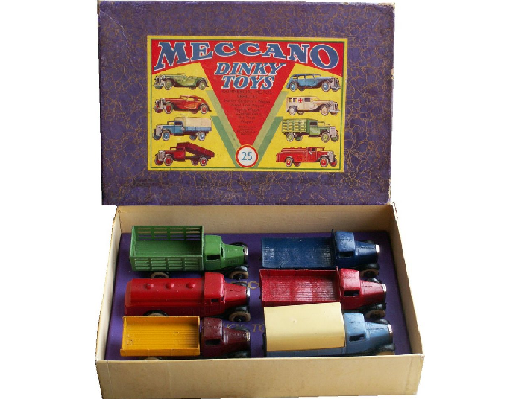


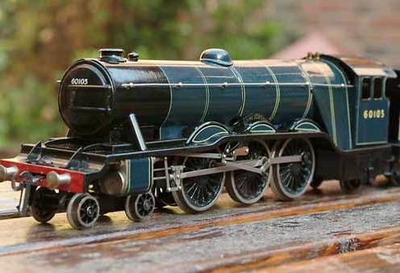

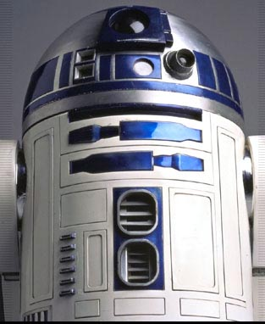



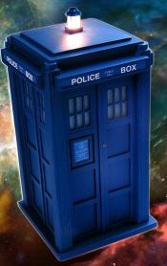

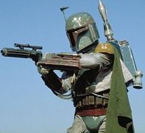
Meet The Real Boba Fett –
Jeremy Bulloch for signings

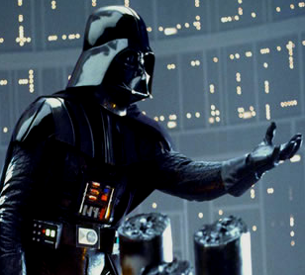

Meet The Real Boba Fett –
Jeremy Bulloch for signings

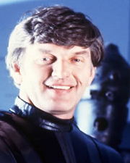
Meet The Real Darth Vader –
Dave Prowse for signings

s
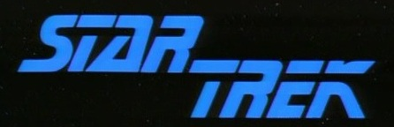

Meet The Real Darth Vader –
Dave Prowse for signings

s

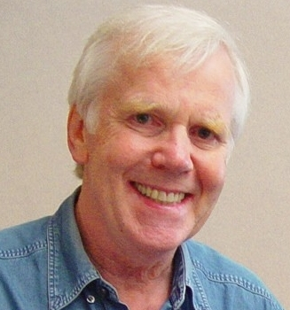
In addition to the vast amount of collectables for sale from everything Sci-Fi toToy Trains and Collectable Cards, Meet characters, see props and more from some of your favourite TV shows and Films including:

- Darth Vader (Dave Prowse)
- K-9
- Dalek
- Aliens v Predators
- R2D2
- TARDIS

- Jeremy Bulloch (Boba Fett)
- Michael Henbury (Ewok)
- Storm Troopers
- The Liberator ship from Blake’s 7
- Cyberman
- ET

AND MORE

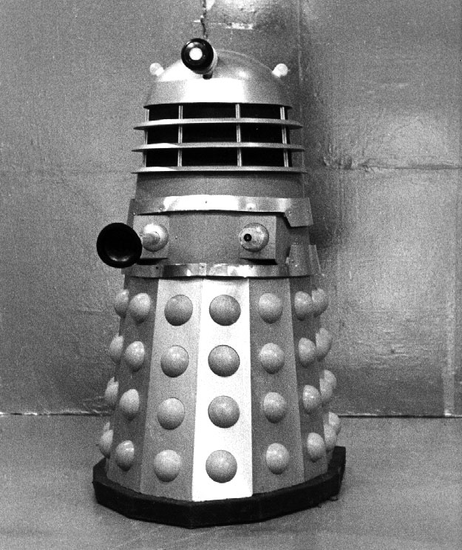

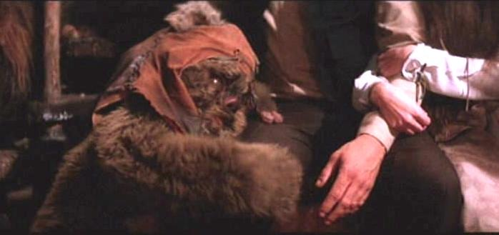
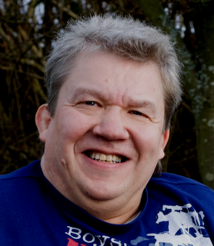
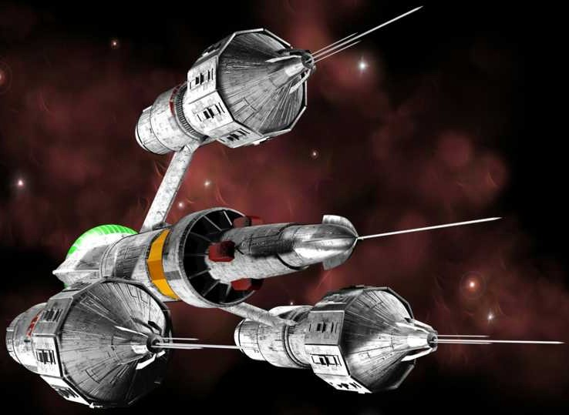

Michael Henbury – Ewok (FIRST APPEARANCE)

Michael Henbury – Ewok (FIRST APPEARANCE)

In addition to the vast amount of collectables for sale from everything Sci-Fi toToy Trains and Collectable Cards, Meet characters, see props and more from some of your favourite TV shows and Films including:

- TARDIS
- Metal Mickey
- The Liberator ship from Blake’s 7
- Storm Troopers

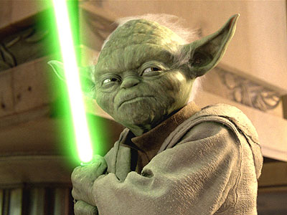
- Darth Vader (Dave Prowse)
- K-9
- Dalek
- Aliens v Predators
- R2D2
- TARDIS

- Jeremy Bulloch (Boba Fett)
- Storm Troopers
- The Liberator ship from Blake’s 7
- Cyberman
- ET
- Michael Henbury (Ewok)

AND MORE

ENTRANCE FEE

Children: £2.00
Children under 5: Free
Adults: £4.00

For Autographs,Separate
charges apply payable to the Actors

DIRECTIONS
Just off Junction 5 of the M27 or Junction 13 of the M3
For further directions visit the Fleming Park Leisure centre website
www.flemingparkleisurecentre.co.uk

Dave Prowse and Jeremy Bullock have confirmed their attendance but their appearance is subject to other commitments, outside of the event organizers control.
Collectables available for sale on the day are subject to cancellation by the dealers, outside of the event organizers control.

ENTRANCE FEE

Children: £2.00
Children under 5: Free
Adults: £4.00

For Autographs,Separate
charges apply payable to the Actors

DIRECTIONS
Just off Junction 5 of the M27 or Junction 13 of the M3
For further directions visit the Fleming Park Leisure centre website
www.flemingparkleisurecentre.co.uk

DEALERS TABLES AVAILABLE

£20.00 Per Table (Tables are included)
For information contact:
Chris on: 07794940309
Email: tarrant8@hotmail.co.uk
Or
David on 07971078275
Email: dj.tarrant69@btinternet.com

Dave Prowse and Jeremy Bullock have confirmed their attendance but their appearance is subject to other commitments, outside of the event organizers control.
Collectables available for sale on the day are subject to cancellation by the dealers, outside of the event organizers control.

DEALERS TABLES AVAILABLE

£20.00 Per Table (Tables are included)
For information contact:
Chris on: 07794940309
Email: tarrant8@hotmail.co.uk
Or
David on 07971078275
Email: dj.tarrant69@btinternet.com

